How to Spot Truth in the Sea of Lies, Rumors, and Myths on the Internet
From: http://lifehacker.com/5950871/how-to-spot-truth-in-the-sea-of-lies-rumors-and-myths-on-the-internet
By: Thorin Klosowski (10/11/12) (Slightly modified by Ms. C-Wallis, signified by [brackets])

The internet is full of crap. For every piece of reputable information you'll find countless rumors, misinformation, and downright falsehoods. Separating truth from fiction is equal parts a mental battle and diligent research. Here's how to make sure you never get duped.

As long as words are hitting the page, news and facts are filtered through someone. Sometimes this is a ludicrous rumor that somehow morphs into a fact, or even just a small tip that doesn't work at all. [like a lot of Pinterest ‘life hacks’] Filtering out the junk from the facts is hard, but it's not impossible.

Why You Shouldn't Trust Your Brain to Spot Truth

Before we start filtering through all the junk, we need to quickly talk about how and why misinformation travels quickly. A number of reasons for this exist, but two are more prevalent than others. First off, we have belief perseverance [perseverance means to keep going], which Scientific America describes like so:

Belief perseverance: maintaining your original opinions in the face of overwhelming data that contradicts [goes against] your beliefs. Everyone does it, but we are especially vulnerable when invalidated beliefs form a key part of how we narrate our lives. Researchers have found that stereotypes, religious faiths and even our self-concept are especially vulnerable to belief perseverance.
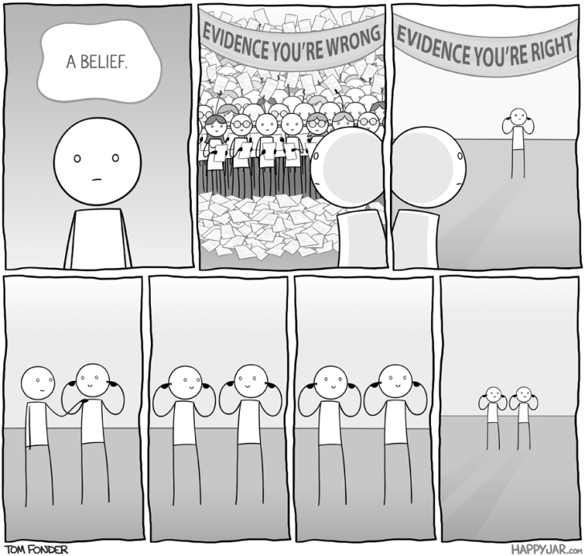
Essentially, once an idea becomes a "fact" in our head, we have a hard time believing that the opposite is true when it's disproven. This is how myths and rumors gain steam.

Belief perseverance also plays well with cognitive bias: flaws in judgement where we make statistical or attribution errors based on patterns. These biases include confirmation bias, where we tend to [favor information that agrees with our opinions and] ignore information we don't agree with, and the bandwagon effect, where we tend to go along with what other members of a group are doing.

Essentially, both make spotting misinformation difficult because we believe just about anything if we want it to be true. The only fix is to acknowledge that you do this. Once you do, it's time to start digging for truly reliable information.

How to Figure Out If Information Is True

Misinformation is everywhere, and although it's tough to find the truth, it's not impossible. Everything ranging from falsified classic quotes to fake experts permeates within our culture. [Here are 5 steps you can take in order to not be fooled:]

- Prime Your Brain with a Simple Question: "How Do You Know What You Know?"
As we mentioned above, our brains aren't as skeptical of information as they should be. Sometimes you have to force it a little to find the real facts. Author Scott Berkun suggests you start this by asking yourself a question:

The first detection tool is a question: “How do you know what you know?” Throw this phrase down when someone force feeds you an idea, an argument, a reference to a ‘study,’ or over-confidently suggests a course of action. People so rarely have their claims challenged that asking someone to explain how they know sheds light on whatever ignorance they’re hiding.

Obviously you don't always have direct access to someone making a claim, but asking yourself that question ("How do they know what they know?") will bring out the skepticism that leads you through the rest of the process.

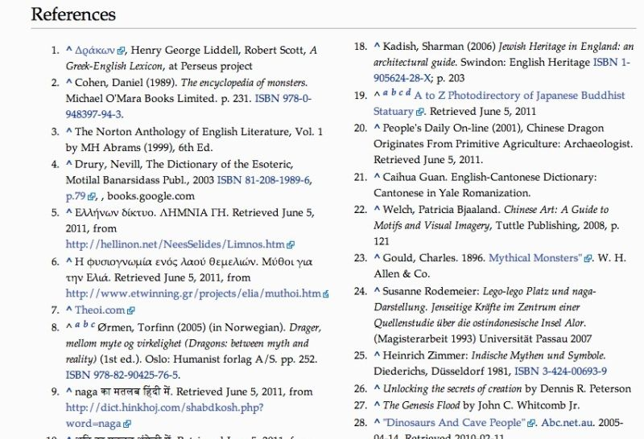
- Follow the Source List and Find the Context for Claims

People interpret information differently. Since news often travels through several sources before it lands in front of you, it's easy for the truth to get lost in the shuffle. This is why following a news story to its original source is important.

Most sites (ours included) have a source list, or a link back to an original story. This is always worth following if something sounds fishy. It's also good to raise your skeptic’s flag when a site doesn't have a source.

Question/answer sites like Quora and Yahoo Answers often pop up first in search results, but that doesn't mean the responder is always a verified expert. Even if a piece of advice or tip from one of these sites sounds legit, it's still worth searching a little deeper before you try anything. If a tipster is really trustworthy, they'll post a link to a source—this is a good place to start. Again, Berkun's question, "How do you know what you know?" is incredibly handy here. If you find a piece of advice online in a forum or question/answer site, search again for the answer by itself to check the validity.

Interviews are also especially deceptive for a number of reasons. First off, quotes might be taken out of context (or made up entirely). The only real recourse is to track down the interview subject (Twitter is often handy for this) and see if the interview subject mentioned anything. Secondly, it's always good to check out experts when they're interviewed in a post. Any good publication will give you their job description, but if something sounds off in an interview it doesn't hurt to search for their name to see other interviews they've done or articles they've written.

- Learn to Ask the Right Questions

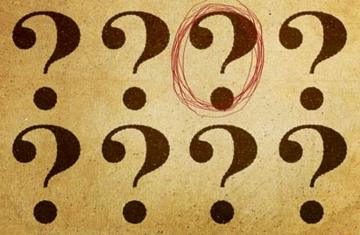
Sometimes getting to the truth requires you to ask a few questions. If something seems off, whether it's a piece of advice, a fact, or something that sounds too good to be true, ask yourself the following questions:

- Is it safe to try this? Whether it's a cleaning tip or dieting advice, the first thing you want to ask yourself is if it's safe to try on your own. You'll find all types of well-meaning advice on forums and question/answer sites, but that doesn't mean they're good. A tip or advice might work for one person, but might be horrible for everyone else. It's always good to try new things, just make sure it's not going to harm your health.

- Is the statement coming from a reputable source? Even reputable sources mess up sometimes, but chances are if you've heard of a publication and they source their information well, you're on track for finding the truth. Take all the iPad Mini rumors as an example. The Wall Street Journal says its coming any day because "some component suppliers to Apple in Asia say they have received orders." Coming from the Wall Street Journal, this sounds great, but who's their source? Who are these component manufacturers? We're not saying an iPad Mini isn't coming—but it's important to notice when a detail is missing.

- Does the person writing this have anything to gain from their statement? Everyone lies a little, but if that person gains something from their lie then it's worth paying close attention to. Whether it's a press kit, someone selling you on their book, their "true" story, or an advertisement, ask yourself if they have something to gain. If they do, the chances for falsehood are increased.

The key here is to ask a question if a statement sounds false. It doesn't matter exactly what the question is, as long as you're asking a question.

- Put More Viewpoints in Front of You

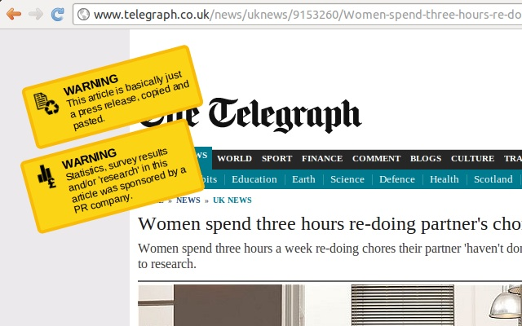
It's best not to leave your skepticism up to your brain on its own. Chances are any major news story (or piece of information) is reported at a lot of different places, and getting those views in front of you can help you fact check information quickly.

To do this, we like the News360 Periscope extension because it instantly shows you different points of view on the story you're reading. This makes it so you can quickly see a highlight of what other people are saying and make a judgement call without doing a lot of work.

We also like the Unsourced extension for Chrome [pictured above]. Unsourced puts a warning label on news stories that are essentially reprints of press releases, links you directly to research sources, and pops up a label when statistics are used. It only works in a handful of places, but it's still handy to keep around.

- Check Dubious Claims Against Trusted Sources

You can't leave everything up to your intuition, which is why plenty of fact checking websites exist. While even these are bound to get things wrong sometimes, they're still a helpful resource when you're deciphering the truth from all the myths, rumors, and lies. Here are a few good places to start.

- Politicfact: Politifact is all about testing the validity of statements by politicians, and in their ads. Right now it's focused mostly on the presidential election (which you can prime your own BS detection skills for), but Politifact typically does a reasonable job of covering the news all year long.
- FactCheck: FactCheck digs into the claims, speeches, and numbers behind political campaigns. If something sounds fishy when you hear it, they're a good place to check.
- Snopes: Snopes.com is best suited for testing the validity of myths and urban legends. It does a good job with it, and provides plenty of resources to back up their claims when possible.

- Truth or Fiction: Truth or Fiction might look like it's stuck in the 90s, but the site still track the truthfulness of all those ridiculous email forwards you get from your family. Spoiler alert: most forwards aren't based on evidence.

Of course, you should remain suspicious even of fact checking sites, but they're a good resource when you're trying to solve the validity of a political quote, or you just want the truth on a juicy urban legend. While you're at it, don't forget to check out our guides to finding reliable medical information and our tips to determine if a scientific statement is true.

