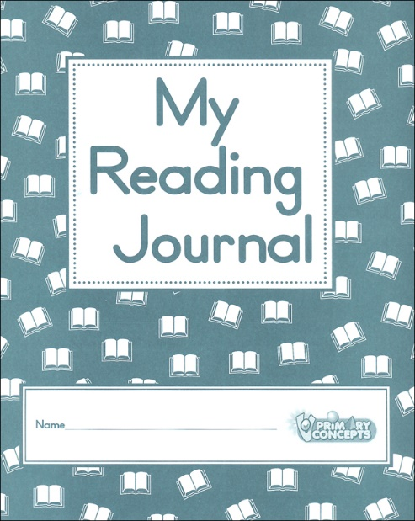
Independent Reading Journal Response
For each section of your reading, please provide the following details in an ongoing Google Doc journal. Be sure to title the journal with your assigned book. Also be aware that this journal will be submitted to turnitin.com at the end of the readings. Please refer to the reading calendar for page ranges for each journal.
Every journal will be worth 8 points in your reading category and will be evaluated on completion, thoroughness, insight, format, and conventions.
There will be an additional 20-point reading reflection for a total of 100 points.

Please use the following format and details to write your journals:
- Journal Number & Chapters/Page Range
- A brief synopsis of reading (generally, what happened or was discussed)
- Character Analysis: Choose a character with significant development or role in the reading and analyze him/her for development, actions, motivations, etc.
OR
Symbol Analysis: Choose an action/event/object that is symbolic in this section and analyze it for meaning as it provides depth to the characters, plot, theme, etc.
- Analyze a quote/passage (with page number) for language, style, tone, theme, etc.
- Vocabulary: Choose 2 words from your reading you needed to define, clarify, or verify and give their part of speech and definition.
- Choose a predominant theme in the reading from the following list to discuss in 3-5 sentences.

  - Adversity/Poverty/Perseverance/ Coping with Hardship
  - Culture/Tradition/ Patriotism/ Nationalism
  - Death/Identity/Value of Life/Time
  - Class/Religious Prejudice
  - Guilt/Disillusion
  - Gender Roles (masculinity/femininity)
  - Education/Growing up/Rite of Passage
  - Family/Social ties/ Relationships/Love

